META4 GALLERY
COURSE OUTLINE: Get Wet in Watercolour (Beginner Level)

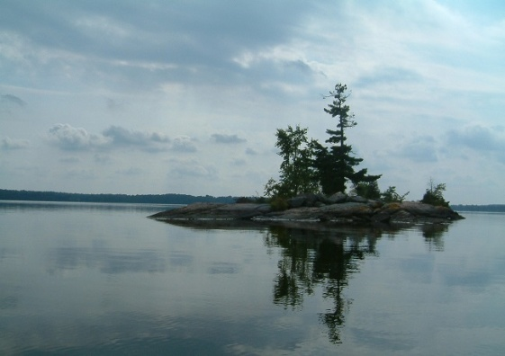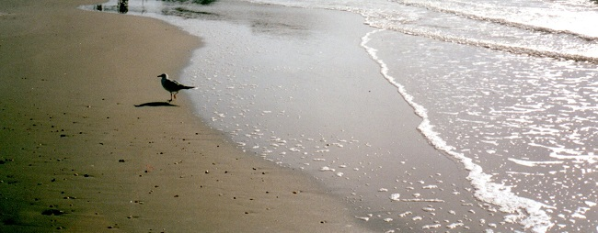
Course Content:
During this six-week workshop, students will paint three or more small paintings with the subject of water. Paint two versions of an island reflected in the calm water of a northern Ontario lake (daytime and sunset), and a seagull on a sandy beach with foamy waves lapping the shore.

Supplied: Instructor Karen Richardson will supply reference photos

Students are asked to bring the following equipment:
- Two quarter-sheets (each measuring 11 x 15" approx) of 300 lb. cold press bright white watercolour paper (d'Arches or equivalent).
- Two sheets of foamcore, coreplast, Masonite or heavy rigid cardboard about 12” x 16” to be used as supports for watercolour paper. If using foamcore or cardboard, waterproof one side with packing tape or shelf liner.
- Watercolour Paints (Winsor & Newton, MaimeriBlu or another Artist quality brand)
  - Yellow: Transparent Yellow, Aureolin, or other brilliant transparent yellow
  - Red: Permanent Alizarin Crimson or other strong transparent red
  - Blue: Antwerp Blue or other strong transparent blue
- Watercolour paint palette with deep paint wells and large flat areas for colour mixing
  - (Instructor uses a Robert E. Woods palette which comes with a lid.)
- Watercolour Brushes:
  - Flat, synthetic, ½ “ wide (used for mixing paint)
  - Flat, synthetic, 1" to 2” wide (used for the backgrounds)
  - Two rounds with a sharp point, size 12 or 14 - larger is fine if you have them (used for most paint application including fine details. Brushes with a blend of genuine sable and synthetic fibres work best. Meta4 sells the Robert Simmons Sapphire brand.)
  - Fine synthetic rigger brush and/or pen-and-ink type dip pen (for applying masking fluid or watercolour)
- HB or 2B pencil
- Pencil sharpener
- Eraser (white plastic is fine)
- Ruler (12” or 18”)
- Layout paper (tracing paper)
- Graphite paper
- Masking Fluid (any colour except white)
- Masking Fluid Eraser
- Small bar of soap in a container (for use with masking fluid)
- Large water container for rinsing brushes (a 2-litre ice cream pail is perfect)
- Roll of masking tape, 1” wide
- Large box of facial tissues, used to prop up your painting support at a comfortable angle
- Cotton rags (pieces of old T-shirt work well)
- Small scraps of watercolour paper for colour testing

